# INDEX.HTML

<!DOCTYPE html>

<html lang="en">

<head>

    <meta charset="UTF-8">

    <meta name="viewport" content="width=device-width, initial-scale=1.0">

    <link rel="stylesheet" href="style.css">

    <link rel="stylesheet" href="https://fonts.googleapis.com/css?family=Poppins">

    <link rel="stylesheet" href="https://fonts.googleapis.com/css?family=Abel">

    <link rel="stylesheet" href="https://fonts.googleapis.com/css?family=Jost">

    <title>Project for Arjun Gurtaj Oluwatobi Samnit</title>

</head>

<body>

    <header>

    <nav>

        <div class="links">

            <a href="#home" id="logo">World of Wonders</a>

            <a href="#home">Home</a>

            <a href="#home">Gallery</a>

            <a href="#home">Contact Us</a>

            <a href="#home" id="search">Search</a>

        </div>

    </nav>

        <h1 id="title">Japan</h1>

        <div class="content">

            <div class="desc">

                <p>Welcome to Japan, a mesmerizing travel destination that seamlessly fuses ancient customs with modern

                    marvels, boasting iconic attractions like Kyoto's serene temples.

                    Nestled in eastern Asia, Japan enchants travelers with its diverse landscapes, from serene coastal

                    towns to bustling metropolises. Delight in Kyoto's timeless allure, adorned with ancient temples and

                    enchanting tea ceremonies. Meanwhile, the awe-inspiring silhouette of Mount Fuji, a sacred volcano

                    with its perfect cone, stands as a breathtaking symbol of Japan's natural beauty. Embark on a

                    journey to this land of the rising sun, where ancient heritage and natural wonders converge in

                    harmony.</p>

    </header>

            </div>

            <div class="container">

                <aside>

                <div class="box" id="box1"><img src="W3Schools_logo.svg" alt="w3schools" width="12%"><a href="https://www.w3schools.com/">

                W3Schools</a></div>

                <div class="box" id="box2"><img src="MDN_Web_Docs_logo.svg" alt="mdn" width="30%"><a href="https://developer.mozilla.org/en-US/">

                MDN Web DOCS </a></div>

                <div class="" id=""><img src=""><a href=""></a></div>  <!-- yaha ek aur website paani hain-->

                </aside>

            </div>

        </div>

        <div class="gallery"> <!-- ye gallery wale section ka alag page hona chahiye aur har page mein header, navigation sidebar aur footer chahiye

         sab same hone chahiye-->

            <h3>01 / Gallery</h3>

            <h1>Must-see attractions for your itinerary</h1>

            <div class="wrapper">

                <div class="card">

                    <img src="arashiyama-bamboo-grove.jpg" alt="arashiyama-bamboo-grove">

                    <p>Arashiyama Bamboo Grove</p>

                    <h5>ARASHIYAMA & SAGANO</h5>

                    <h4>Arashiyama Bamboo Grove in Japan is a mesmerizing natural wonder. Towering bamboo stalks form a mystical pathway, casting intricate patterns of light and shadow...</h4>

                </div>

                <div class="card">

                    <img src="arashiyama-bamboo-grove.jpg" alt="arashiyama-bamboo-grove">

                    <p>Arashiyama Bamboo Grove</p>

                    <h5>ARASHIYAMA & SAGANO</h5>

                    <h4>Arashiyama Bamboo Grove in Japan is a mesmerizing natural wonder. Towering bamboo stalks form a mystical pathway, casting intricate patterns of light and shadow...</h4>

                </div>

                <div class="card">

                    <img src="meguro-river.jpg" height="400.04" width="205.04" alt="arashiyama-bamboo-grove">

                    <p>Meguro River</p>

                    <h5>NAKA MEGURO</h5>

                    <h4>The Meguro River is a river which flows through Tokyo, Japan. Its tributaries include the Kitazawa River and the Karasuyama River. The river flows into Tokyo Bay near the Tennōzu Isle Station.</h4>

                </div>

            </div>

        </div>

</body>

<footer> <!-- iski styling wagera dekh liyo-->

    <p>Website Made By:-</p>

    <p>ARJUN NARANG</p>

    <p>SAMNIT SAMNIT </p>

    <p>GURTAJ SINGH</p>

    <p>OLUWATOBI ABDULKABIR AWONUGA</p>

    <p><a href="https://www.niagaracollegetoronto.ca/">Niagara College Toronto</a></p>

</footer>

</html>

# Style.css

body{

    margin: 0;

    padding: 0;

}

*{

    font-family: Poppins;

}

nav{

    border-radius: 25px;

    background-image: url(mount-fuji.jpg);

    padding: 0.75rem;

    font-family: Poppins, Arial, Helvetica, sans-serif;

    font-weight: bold;

    font-size: large;

    padding-bottom: 500px;

    margin: 25px;

    background-position: center;

}

a{

    text-decoration: none;

    color: whitesmoke;

    padding: 0 20px 0 20px;

    text-align: end;

}

#search{

    text-shadow: none;

    background-color: white;

    border-radius: 25px;

    color: black;

    padding-top: 2px;

    padding-bottom: 2px;

}

#logo{

    flex: 6;

    text-align: start;

}

.links{

    display: flex;

    margin: 20px;

}

#title {

    margin: 25px;

    margin-top: 75px;

    font-size: 80px;

    font-weight: bold;

    color: rgb(34, 119, 255);

}

.content{

    margin: 25px;

    display: flex;

}

.desc{

    flex: 1.5;

    margin-bottom: 75px;

    color: rgb(90, 90, 90);

    margin-right: 20px;

}

.container{

    flex: 1;

    display: flex;

}

.box{

    flex: 1;

    background-color: #e5f0e3;

    margin: 10px;

    margin-left: 10px;

    border-radius: 16px;

}

#box2{

    background-color: #f5e2e6;

}

.box img{

    margin: 8%;

}

.gallery{

   background-color: aliceblue;

   padding: 4%;

    margin: 25px;

    border-radius: 25px;

}

.gallery h3{

    font-family: Abel;

    letter-spacing: 2px;

    word-spacing: 4px;

}

.gallery h1{

    font-size: 50px;

}

.wrapper{

    display: flex;

}

.card{

    margin: 20px;

    font-weight: bold;

    font-family:  Helvetica, sans-serif;

    font-size: 20px;

}

.card h5{

    font-family: Abel;

    font-size: 14px;

    margin-top: 0;

}

.card h4{

    font-size: 15px;

    font-weight: normal;

}

.card img{

    border-radius: 25px;

    flex: 1;

    width: 100%;

    justify-content: space-around;

}

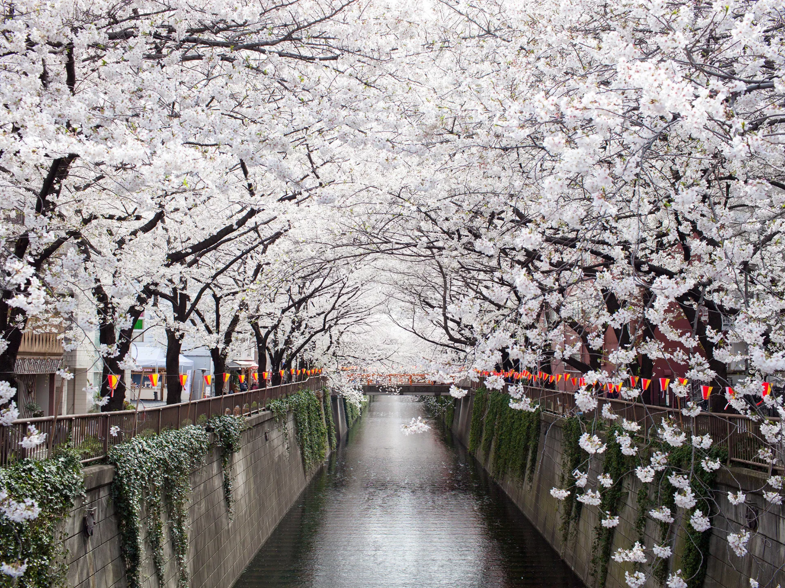

meguro-river.jpg